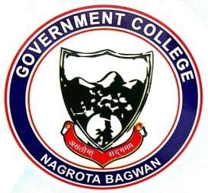
GOVERNMENT COLLEGE
NAGROTA BAGWAN
Distt. Kangra (H.P.)-176047
Tel.: 01892-251177
EMAILID: gcnagrotabagwan@gmail.com

Detail of Professional Ethics Programs organized by the Institution for Students, Teacher, Administrator and other Staff during 2022-23

- One week workshop on Essentials of computer series -1 (EOC-SI) on dated 24-Aug-22
http://gdcnb.org/wp-content/uploads/2024/04/Report-on-one-week-workshop-essentials-of-computer-series-BCA-Department.pdf

- Induction cum Orientation program for BBA student on dated 29-Aug-22
http://gdcnb.org/wp-content/uploads/2024/04/INDUCTION-REPORT-BBA.pdf

- Seminar on Share Market and Employment Opportunities on dated 15-Nov-22
http://gdcnb.org/wp-content/uploads/2024/04/Seminar-on-Share-Market-and-Employment-Opportunities.pdf

- Workshop on the Stock Market on dated 14-Dec-22
http://gdcnb.org/wp-content/uploads/2024/04/Workshop-on-the-Stock-Market.pdf

- Job Fair Organized by Commerce Society on dated 26-Dec-22
http://gdcnb.org/wp-content/uploads/2024/04/Job-Fair-Organized-by-Commerce-Society.pdf

- Industrial visit organized by the commerce society on dated 24-Jan-23
http://gdcnb.org/wp-content/uploads/2024/04/Industrial-Visit.pdf

- Industrial Visit by Department of BCA on dated 02-Mar-23
http://gdcnb.org/wp-content/uploads/2024/04/BCA-Industrial-Visit.pdf

- Work Shop on Financial Wellness Programme on dated 25-Mar-23
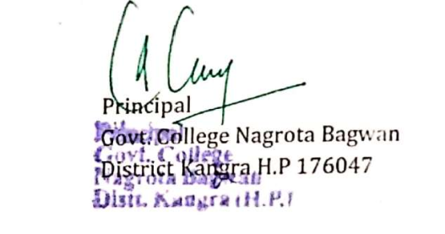
http://gdcnb.org/wp-content/uploads/2024/04/Work-Shop-on-Financial-Wellness-Programme.pdf

